KIRCHOFF’S CURRENT LAW:

**Kirchhoff's Current Law**, often shortened to KCL, states that “The algebraic sum of all currents entering and exiting a node must equal zero.” This law is used to describe how a charge enters and leaves a wire junction point or node on a wire.

V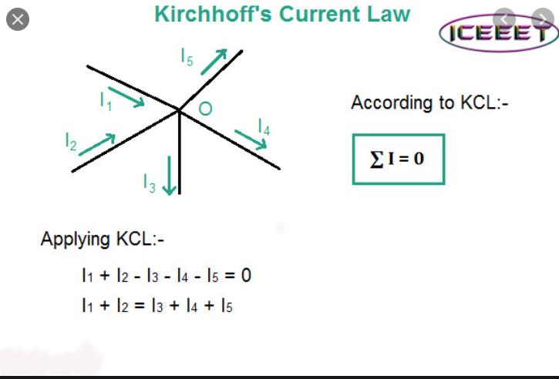

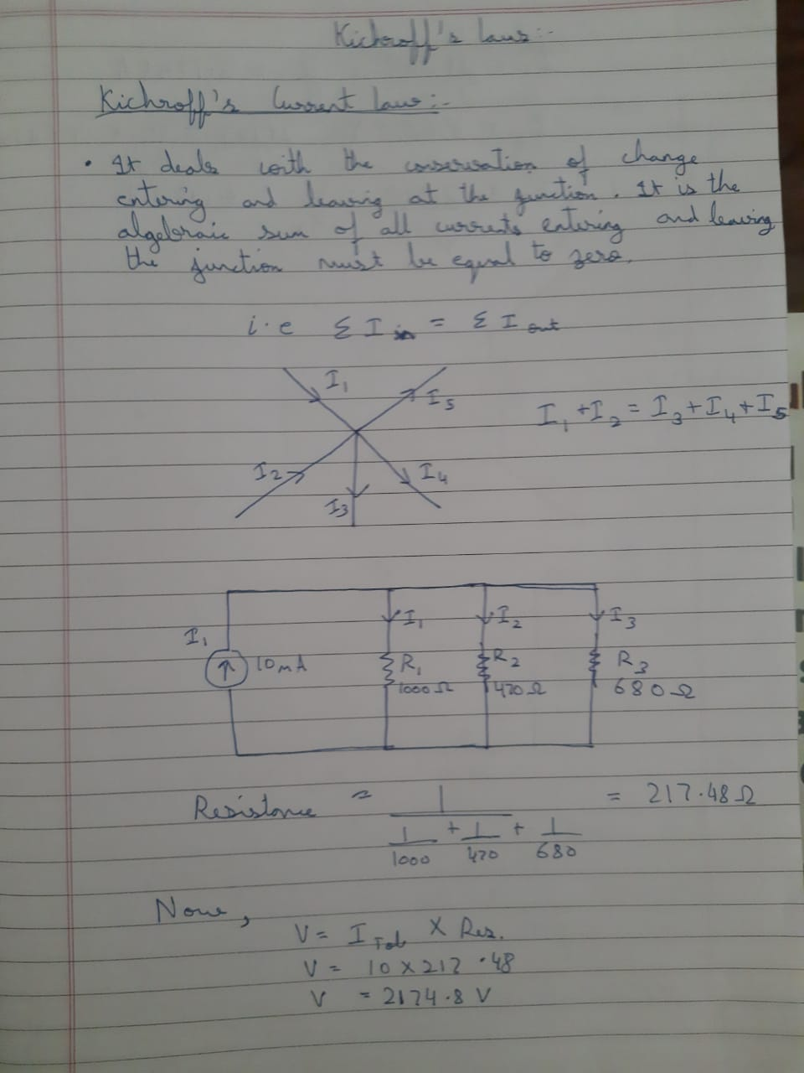

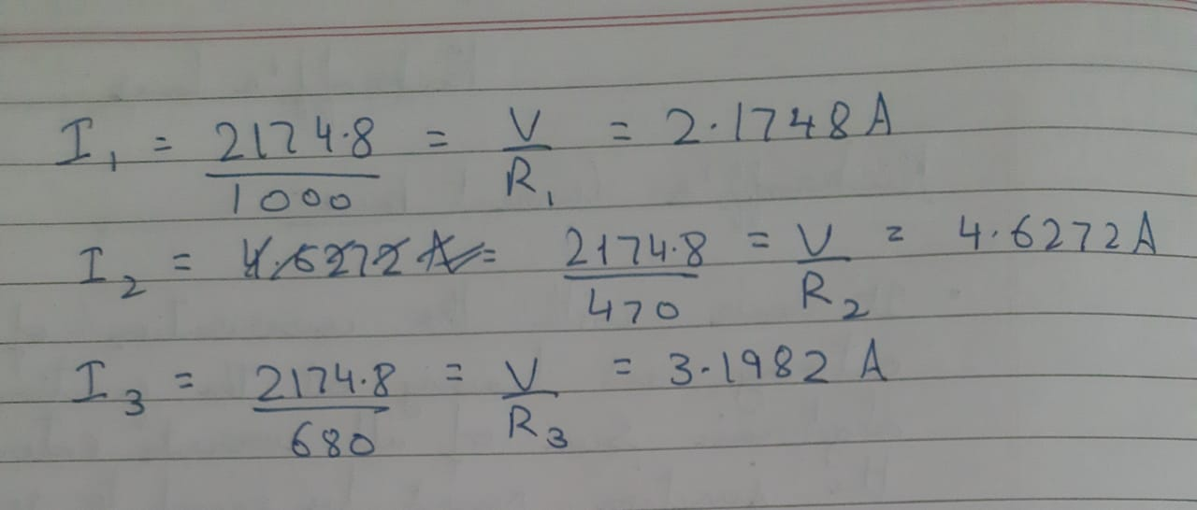

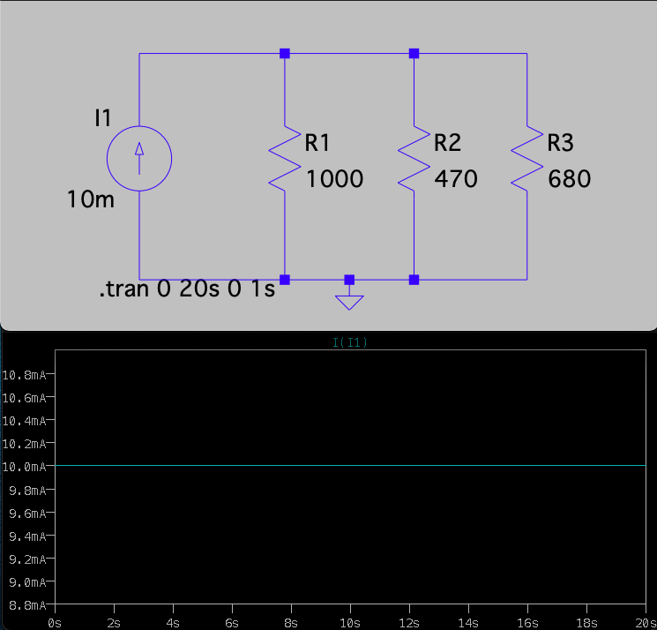

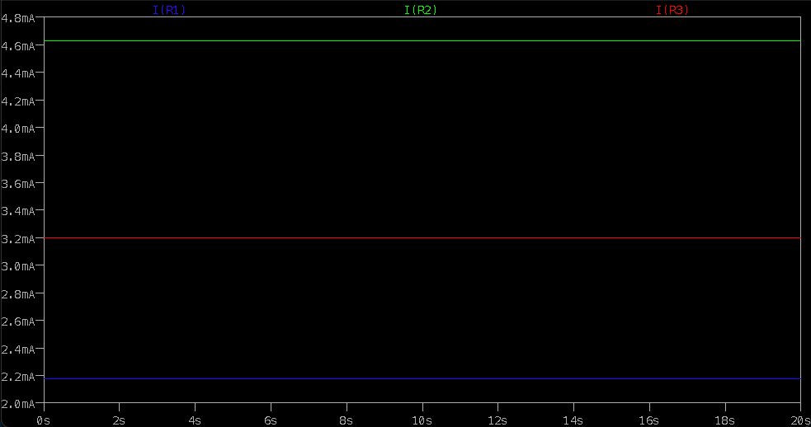

KIRCHOFF’S VOLTAGE LAW:

**Kirchhoff's Voltage Law (KVL)** is Kirchhoff's second law that deals with the conservation of energy around a closed circuit path. ... His voltage law states that for a closed loop series path the algebraic sum of all the voltages around any closed loop in a circuit is equal to zero.

